Angebot freibleibend - Zwischenverkauf vorbehalten / free offer - subject to being unsold

S N E A K E R - Different Brands of MUSTANG Spain (Warehouse Germany)

Item image / Artikelbild | Model | Brand | Color / Farbe | Gender | Size | Qty per | Boxes | Total pairs |  | Qty per
 |  |  |  |  |  | Box | Boxes | Total pairs |  | Model
 | 20549 |  | CANVAS MARINO | Kids | 28 - 37 | 14 | 51 | 714
 | 20549 |  | CANVAS ROJO | Kids | 28 - 37 | 14 | 75 | 1.050 | 1.764
 | 55549 |  | CANVAS BLANCO | Women | 36 - 41 | 12 | 210 | 2.520
 | 55549 |  | CANVAS ROJO | Women | 36 - 41 | 12 | 10 | 120
 | 55549 |  | CANVAS ROSA | Women | 36 - 41 | 12 | 8 | 96
 | 55549 |  | FLUORITO NARANJA FLUOR | Women | 36 - 41 | 12 | 12 | 144
 | 55549 |  | FLUORITO VERDE FLUOR | Women | 36 - 41 | 12 | 5 | 60
 | 55549 |  | CANVAS MARINO | Women | 36 - 41 | 12 | 232 | 2.784
 | 55549 |  | CANVAS NEGRO | Women | 36 - 41 | 12 | 164 | 1.968 | 7.692
 | 55638 |  | CANVAS NEGRO / TEJIDO VERDE FLUOR | Women | 35 - 40 | 12 | 125 | 1.500
 | 55638 |  | FLUORITO ROSA | Women | 35 - 41 | 12 | 125 | 1.500
 | 55638 |  | FLUORITO VERDE | Women | 36 - 41 | 12 | 53 | 636
 | 55638 |  | PU NOBUCK AZUL | Women | 35 - 40 | 12 | 36 | 432
 | 55638 |  | PU NOBUCK FUCSIA | Women | 35 - 40 | 12 | 79 | 948
 | 55638 |  | PU NOBUCK ROJO | Women | 35 - 40 | 12 | 100 | 1.200 | 6.216
 | 20638 |  | PU NOBUCK FUCSIA | Kids | 28 - 37 | 14 | 10 | 140
 | 20638 |  | PU NOBUCK AZUL | Kids | 28 - 37 | 14 | 3 | 42
 | 20638 |  | PU NOBUCK GRIS | Kids | 28 - 37 | 14 | 1 | 14
 | 20638 |  | FLUORITO ROSA FLUOR | Kids | 28 - 37 | 14 | 21 | 294
 | 20638 |  | FLUORITO VERDE FLUOR | Kids | 28 - 37 | 14 | 31 | 434
 | 20638 |  | FLUORITO AMARILLO FLUOR | Kids | 28 - 37 | 14 | 20 | 280 | 1.204
 | 55640 |  | CANVAS GRIS / NEGRO | Women | 35 - 40 | 12 | 10 | 120
 | 55640 |  | CANVAS KAKHI / BEIGE | Women | 35 - 41 | 12 | 87 | 1.044 | 1.164
 |  |  | CANVAS NEGRO / FLUORITO VERDE
 | 13992 |  | FLUOR | Women | 35 - 40 | 12 | 58 | 696
 | 13992 |  | PU NOBUCK FUCSIA | Women | 35 - 40 | 12 | 62 | 744 | 1.440
 | 15381 |  | CANVAS RED | Men | 40 - 45 | 12 | 3 | 36
 | 15381 |  | PU NOBUCK NEGRO | Men | 40 - 45 | 12 | 10 | 120
 | 15381 |  | PU NOBUCK VAQUERO | Men | 40 - 45 | 12 | 45 | 540 | 696
 | 75071 |  | TAPESTRY NEGRO | Women | 36 - 41 | 9 | 56 | 504 | 504
 | 91075 |  | NEGRO | Men | 40 - 44 | 6 | 4 | 24 | 24
 | 81200 |  | PU NOBUCK AZUL | Kids | 28 - 37 | 14 | 21 | 294
 | 81200 |  | PU NOBUCK FUCSIA | Kids | 28 - 37 | 14 | 7 | 98
 | 81200 |  | PU NOBUCK VAQUERO | Kids | 28 - 37 | 14 | 4 | 56
 | 81200 |  | PU NOBUCK GRIS | Kids | 28 - 37 | 14 | 4 | 56 | 504
 | 56405 |  | CROSTA GRIS CLARO / NYLON GRIS CLARO | Women | 36 - 41 | 12 | 1 | 12 | 12
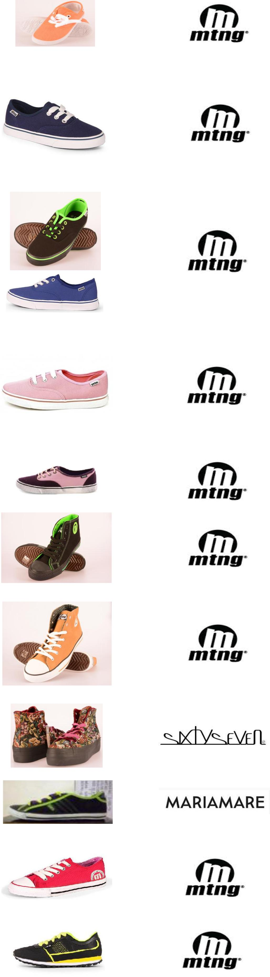

Seite 1 von 2

Angebot freibleibend - Zwischenverkauf vorbehalten / free offer - subject to being unsold

S N E A K E R - Different Brands of MUSTANG Spain (Warehouse Germany)

Item image / Artikelbild | Model | Brand | Color / Farbe | Gender | Size | Qty per | Boxes | Total pairs | Qty per
 |  |  |  |  |  | Box | Boxes | Total pairs | Model
 | 80638 |  | PU NOBUCK ROJO | Men | 40 - 45 | 12 | 9 | 108 | 108
 | 80640 |  | CANVAS KAKHI / BEIGE | Men | 40 - 45 | 12 | 21 | 252 | 252
 | 16078 |  | SERRAJE MARINO | Women | 36 - 41 | 12 | 2 | 24
 | 16078 |  | SERRAJE VINO | Women | 36 - 41 | 12 | 1 | 12 | 36
 | 75070 |  | LAREDO NEGRO | Women | 36 - 41 | 12 | 20 | 240
 | 75070 |  | TAPESTRY NEGRO | Women | 36 - 41 | 9 | 23 | 207
 | 75070 |  | WAR VERDE | Women | 36 - 41 | 9 | 4 | 36
 | 75070 |  | LEOPARDO NATURAL | Women | 36 - 41 | 12 | 29 | 348
 | 75070 |  | WAR VERDE | Women | 36 - 41 | 12 | 1 | 12 | 843
 | 75378 |  | SACHI NEGRO / SCARVE NAVY | Women | 36 - 41 | 9 | 2 | 18 | 18
 | 56401 |  | CROSTA AZUL | Women | 36 - 40 | 9 | 1 | 9
 | 56401 |  | CROSTA NEGRO | Women | 36 - 40 | 9 | 1 | 9
 | 56401 |  | CROSTA ROJO / GRIS | Women | 36 - 40 | 9 | 1 | 9 | 27
 |  |  | ANTELINA BURDEOS / COLORADO
 | 69332 |  | NATURAL | Women | 35 - 41 | 9 | 1 | 9 | 9
 | 82549 |  | CANVAS MARINO | Men | 40 - 45 | 12 | 9 | 108
 | 82549 |  | MILITARY GRIS | Men | 40 - 45 | 12 | 1 | 12 | 120
 | 82800 |  | CANVAS BLANCO | Men | 40 - 45 | 12 | 1 | 12
 | 82800 |  | CANVAS ROJO | Men | 40 - 45 | 12 | 1 | 12 | 24
 | 69120 |  | ANTELINA TAUPE | Women | 36 - 40 | 8 | 1 | 8
 | 69120 |  | LEOPARDO CAMEL | Women | 36 - 40 | 8 | 1 | 8 | 16
TOTAL |  |  |  |  |  |  |  | 22.673
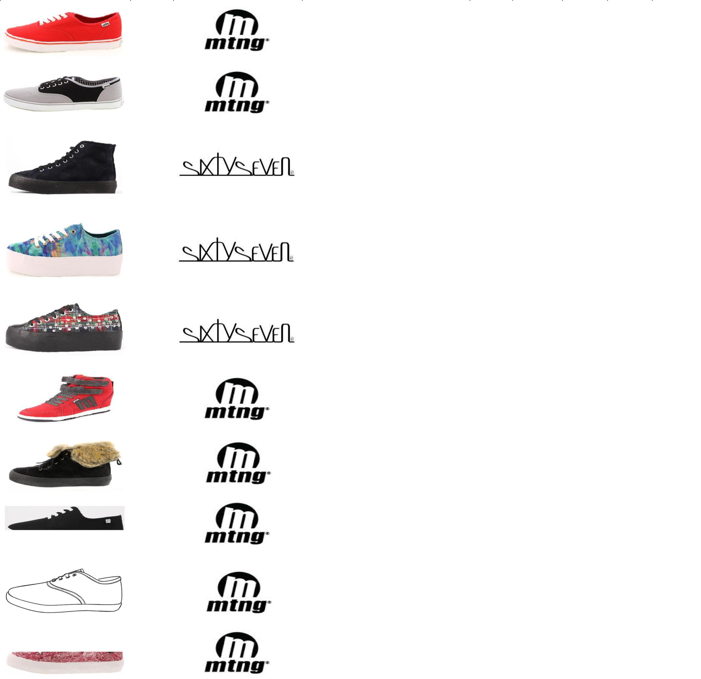
Abgebildetes Modell auf den Bildern entspricht nicht immer der vorhandenen Farbe, es sind Beispielbilder für Modell. / The model shown in the pictures is not always the existing color, there are sample images for model.

Bitte beachten Sie, dass es sich in unseren Angeboten nur um circa Sückzahlen handelt, die genauen Stückzahlen können erst beim Packen ermittelt werden.

Please note, that the given quantities in our offers are only approximately, the exact numbers are only indentifiable after packing.

Seite 2 von 2

